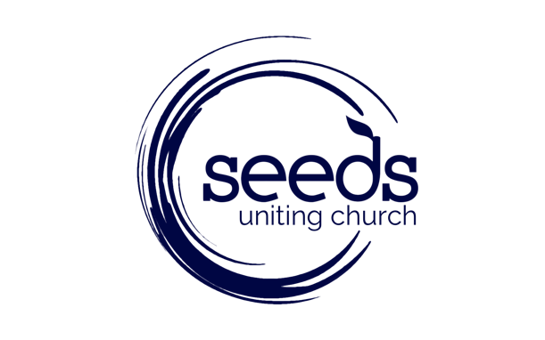

Church Council / Elders Information

Church Council is seeking expressions of interest from within the membership of the Seeds congregation to fill four vacancies on Church Council. The vacancies are a result of existing Elders completing their nominated term. The Elders continuing in their role are as follows: Jonathan Carpenter, Simon Malcolm, Bob Buxton and Deb Mugford.
Elders make up the Church Council and together with the Senior Pastor have responsibility for the spiritual oversight over the congregation and a governance role to ensure the Church operates responsibly and in accordance with the Uniting Church regulations.
Church Council meets at least monthly on the third Monday of each month at 6.30pm. Additional meetings are held when required and Elders are expected to take on other responsibilities and serve on sub committees as required.

What are the Attributes of an Elder?
- Love the Lord and a commitment to grow in faith through prayer, reading the Bible, participating in worship and contributing to the life of the Seeds Uniting Church community.
- A commitment to the Seeds Mission Statement; Bringing people to Jesus and being transformed into His passionate disciples.
- Demonstrable spiritual gifts and willingness to use and develop those gifts.
- Ability to work in a team, to listen carefully to others, participate in constructive and respectful discussion and seek God’s direction in decisions.

How to submit an Expression of Interest?
Nominees are invited to respond to the following four questions. The questions are seeking to assist you in the discernment process of being called to be an Elder.

- Why do you feel called to be an Elder?

- The Seeds Mission Statement is; Bringing people to Jesus and being transformed into His passionate disciples. Can you describe how you are contributing to this Mission Statement?

- What do you see as your main spiritual gift or gifts?

- Can you briefly describe a recent faith experience?

The application form can be found on the Seeds website or alternatively you can contact Sarah Beresford – Executive Assistant to the Senior Pastor by email: sarah.beresford@seedschurch.org or pick up a hard copy from the front office.

What is the Process?

All Expressions of Interest will be confidential.

- A panel, appointed by Church Council and consisting of; The Senior Pastor, an Elder and a congregational representative will receive the expressions of interest.

- Each applicant will be contacted by the panel between 17th and 28th of August where there will be an opportunity to discuss further their expression of interest.

- Following the receiving of the form and through discussion with the panel and prayerful consideration - if both the applicant and the panel agree, then the name will be recommended to Church Council for endorsement.

- Council will call for a congregational vote where the Seeds congregation will elect the new Elders to serve on Church Council.

Nomination and Election Dates

- Sunday 26th July – Expressions of Interest Open
- Sunday 9th August 5pm– Expressions of Interest Close
- Sunday 30th August - Nominees announced
- Monday 7th September - Congregational Vote

