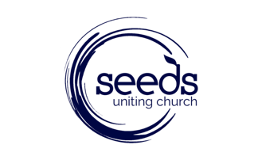

Church Council / Elders Expression of Interest Form

Thank you for your interest in Eldership, we welcome your Expression of Interest. This Expression of Interest form is designed to assist you in discerning your call to be an Elder. All Expressions of Interest will be confidential.

Name:
Email:
Phone Number:
You are invited to respond to the following questions. Responses can be brief although there is no restriction as to the length.
- Why do you feel called to be an Elder?

- The Seeds Mission Statement is; Bringing people to Jesus and being transformed into His passionate disciples. Can you describe how you are contributing to this Mission Statement?

- What do you see as your main spiritual gift or gifts?

- Can you briefly describe a recent faith experience?

What Happens Next?

- A panel, appointed by Church Council and consisting of; The Senior Pastor, an Elder and a congregational representative will receive the expressions of interest.

- Each applicant will be contacted by the panel between 17th and 28th August where there will be an opportunity to discuss further with you your expression of interest.

- Following the receiving of the form and through discussion with you, the panel and with prayerful consideration - if both the applicant and the panel agree, then the name will be recommended to Church Council for endorsement.

- Council will call for a congregational vote where the Seeds congregation will elect the new Elders to serve on Church Council .

Closing Dates and How to Submit an Expression of Interest
- Sunday 26th July - Expressions of Interest Open
- Sunday 9th August 5pm - Close Expressions of Interest
Forms can be marked Confidential and submitted to Sarah Beresford – Executive Assistant to the Senior Pastor by email: sarah.beresford@seedschurch.org or in hard copy at the office.

